Hello my fellow Pioneers!
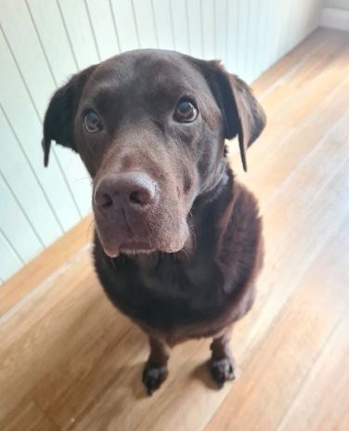
My name is Mr Cornell and I’m going to be your Class Teacher this term. I’m so excited to meet you all and get to know everyone. Over the weeks ahead there will be lots of fun and interesting lessons planned, YOU’RE GOING TO HAVE A BLAST!
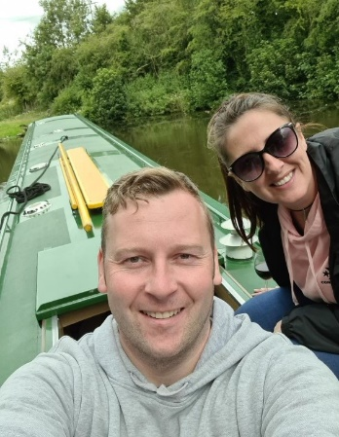
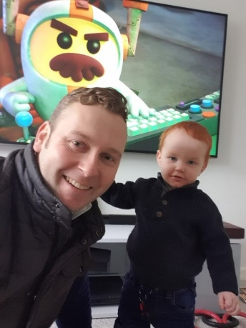
But who is Mr Cornell? He’s not from Fishburn, I wonder what he likes?
In my spare time, I love travelling and have visited many different places around the world, some hot countries like Dubai which was 48 degrees Celsius and some very cold countries like Norway which was an amazing -25 degrees Celsius, it was FREEZING! This year I have been discovering Northern Ireland and the Ilse of Arran. The Ilse of Arran is like a secret island off the mainland of Scotland and to get there I had to catch a ferry! My Chocolate Labrador Maggie came with me. She also loves to travel and explore new places. You may bump into us one day on one of our regions gorgeous beaches as she loves nothing more than going for a swim and play fetch with her ball! But when I’m not exploring on my travels me and Maggie always drive to see our family members and spend as much time as possible with them especially my Niece and two Nephews who are the same age as you!

My favourites…
Colour – Blue Hobby – exploring EVERYWHERE!
Food – My Mam’s Sunday Dinner (That’s why I go home on a Sunday, but that’s our secret!)
Drink – Orange juice Animal – Dog (Maggie wouldn’t allow any different!)
Season – Spring Book – Gangsta Granny (She reminds me of mine!)
Country – Dubai City – Brussels (an amazing city and is the capital of Belgium)

Enough about me, let’s find out about you…. See you soon!
Mr Cornell.

